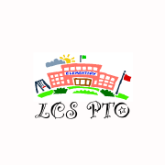

Save the Date!
8th Annual Buddies and Books Café
Thursday, March 7th, 2013

6:30 - 7:30 pm ~ LCS Cafeteria

Bring your family and favorite buddy (stuffed animal) for a fun-filled evening of reading and sharing

Choose from a menu of outstanding books to enjoy with your family

Open to children in grades k – 3
Members of our Fifth Grade class will proudly serve


Stuffed Animal Collection

Donate your gently used stuffed animals to benefit Joshua’s Closet
All donations support cancer research

Information on collection Dates to Follow in the Friday Folder.

Thank you for your generosity and support!

